**GUVI**

E-commerce Plant Shop Website

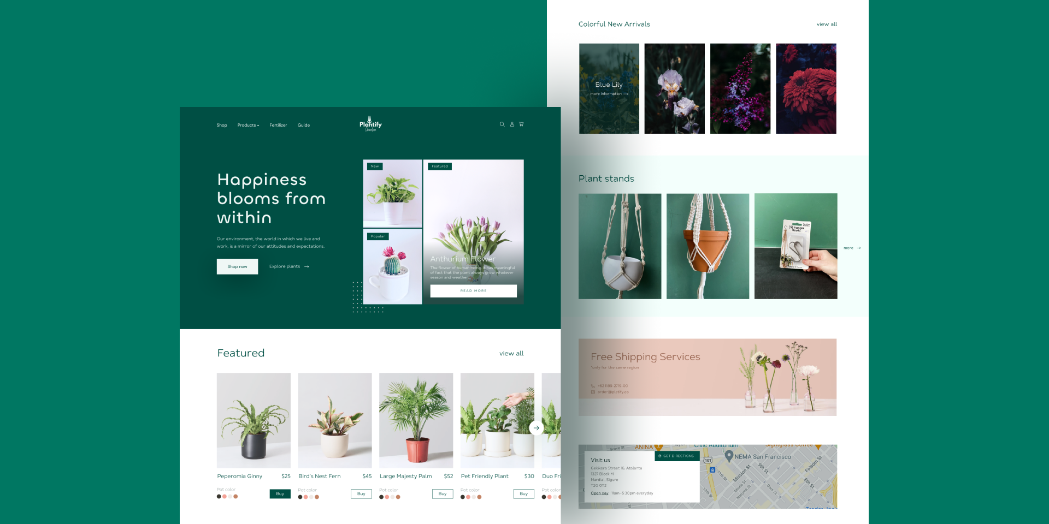

**TASK:**

**Business and Functional Requirements:**

**a. Product Catalog Management:**

1. Ability to add, edit, and delete products.
2. Product categorization and filtering.
3. Product descriptions, images, and videos.

**b. User Accounts:**

1. User registration and authentication.
2. User profiles

**c. Shopping Cart:**

1. Adding/removing products to/from the cart.
2. Updating cart contents.
3. Calculating cart totals (subtotal, tax, shipping).
4. Saving shopping carts for later.

**d. Search and Navigation:**

1. Robust search functionality.
2. Filters and sorting options.
3. Product recommendations and related products.

**e. Reviews and Ratings:**

1. Customer reviews and ratings for products.

**TASK DETAILS:**

**1. Any specifications and constraints?**

CSS Frameworks-React-Bootstrap

Use ReduxToolkit for state management

Use mockapi.io for storing product(plant) details

**2. How do I submit my work?**

* + Push all your work files to your Github(<https://github.com/>)
  + URL format has to be followed for both Github and Netlify.
    - [https://github.com/username/](https://github.com/username/covid19-visualizer-yourname)projectname
  + Deploy your site in netlify([/https://www.netlify.com](https://www.netlify.com)/).
  + Submit your task .

**3. Terms and Conditions?**

* You agree to not share this confidential document with anyone.
* You agree to open-source your code (it may even look good on your profile!). Do not mention our company’s name anywhere in the code.
* We will never use your source code under any circumstances for any commercial purposes; this is just a basic assessment task.

**NOTE:** Any violation of Terms and conditions is strictly prohibited. You are bound to adhere to it.